**Digital Steganography**

**A PROJECT REPORT**

**for**

**Mini Project (ID201B)**

**Session (2024-25)**

**Submitted by**

**(GC-14)**

**Rahul Rawat**

**(202410116100159)**

**Prince Yadav**

**(202410116100150)**

**Priyanshu Asthana**

**(202410116100154)**

**Submitted in partial fulfilment of the**

**Requirements for the Degree of**

**MASTER OF COMPUTER APPLICATION**

**Under the Supervision of**

**Ms. Shweta Singh**

**Associate Professor**



**Submitted to**

**Department Of Computer Applications**

**KIET Group of Institutions, Ghaziabad**

**Uttar Pradesh-201206**

**(May 2025)**

### DECLARATION

We hereby declare that the work presented in this project entitled **“Digital Steganography”** was carried out by us. We have not submitted the matter embodied in this report for the award of any other degree or diploma of any other University or Institute.

We have given due credit to the original authors/sources for all the words, ideas, diagrams, graphics, computer programs, experiments, results, that are not my original contribution. We have used quotation marks to identify verbatim sentences and given credit to the original authors/sources.

We affirm that no portion of my work is plagiarized, and the experiments and results reported in the report are not manipulated. In the event of a complaint of plagiarism and the manipulation of the experiments and results, we shall be fully responsible and answerable.

**Rahul Rawat (202410116100159)**

**Prince Yadav (202410116100150)**

**Priyanshu Asthana (202410116100154)**

**CERTIFICATE**

Certified **Prince Yadav (202410116100150), Rahul Rawat (202410116100159), Priyanshu Asthana (202410116100154)** has/ have carried out the project work having “**Digital Steganography**” for Master of Computer Applications from Dr. A.P.J. Abdul Kalam Technical University (AKTU**)** (formerly UPTU), Technical University, Lucknow under my supervision. The project report embodies original work, and studies are carried out by the student himself / herself and the contents of the project report do not form the basis for the award of any other degree to the candidate or to anybody else from this or any other University/Institution

**Ms. Shweta Singh Dr. Akash Rajak**

**Assistant Professor Dean**

**Department of Computer Department of Computer Applications Applications**

**KIET Group of Institutions KIET Group of Institutions**

**ABSTRACT**

In an era marked by pervasive digital communication, ensuring the **confidentiality and integrity** of sensitive information has become a paramount concern, especially for corporate, governmental, and defence organizations. With increasing cyber threats and data interception incidents, organizations are compelled to seek secure and unobtrusive communication channels. Traditional **cryptographic methods**, while highly secure, often attract attention due to their visibly encrypted content, which may indicate the presence of confidential data to adversaries.

To address this concern, the project titled **“Digital Steganography”** introduces an innovative data concealment strategy that emphasizes **stealth and security**. The system is designed to embed secret information within standard **digital image files**, such as PNG or BMP, using advanced encoding techniques that manipulate image pixels without perceptibly altering the visual quality. This method ensures that the **hidden message remains invisible** to the human eye and undetectable by casual inspection, offering a covert yet efficient medium for secure communication.

Developed using the **Java programming language**, the system leverages powerful Java-based libraries like java x. image Io and optional encryption through javax.crypto to enhance both usability and protection. The graphical user interface (GUI), built using **Swing or JavaFX**, provides a user-friendly environment for encoding and decoding processes. Furthermore, the system is designed with **scalability and resilience** in mind. It can be enhanced to support larger payloads, multiple file types, or even hybrid techniques that combine encryption and steganography. By focusing on **invisibility, accessibility, and adaptability**, Digital Steganography redefines the boundaries of **secure information exchange**. This project not only addresses contemporary security challenges but also contributes to the evolving landscape of **information hiding techniques** and **cyber defence technologies**.

**Keywords**: Digital Steganography, Data Hiding, Information Security, Java, Cryptography, Secure Communication, Covert Transmission

**ACKNOWLEDGEMENT**

Success in life is never achieved alone. I express my deepest gratitude to my thesis supervisor, Dr. Sangeeta Arora (Associate Professor), for her guidance, assistance, and encouragement throughout my project work. Her insightful ideas, comments, and suggestions have been invaluable in helping me complete this project successfully.

I am also immensely grateful to Dr. Akash Rajak, Professor and Head of, the Department of Computer Applications, for his valuable feedback and administrative support on several occasions. I am fortunate to have many supportive friends who have been of great help during critical moments of this journey.

Lastly, I would like to extend my heartfelt thanks to my family members and all those who have provided me with moral support and assistance, both directly and indirectly. Completing this work on time would not have been possible without their unwavering support. Their constant love and encouragement have filled my life with joy and happiness.

**Rahul Rawat**

**Priyanshu Asthana**

**Prince Yadav**

**TABLE OF CONTENTS**

|  |  |  |  |
| --- | --- | --- | --- |
|  | Certificate | | ii |
|  | Abstract | | iii |
|  | Acknowledgments | | iv |
|  | Table of Contents | | v-vi |
|  | List of Figures | | vii |
| **1** | **Introduction** | | **1-6** |
|  | 1.1 | Background | 1 |
|  | 1.2 | Problem Review | 1 |
|  | 1.3 | Objective | 2 |
|  | 1.4 | Key Features | 2 |
|  | 1.5 | Scope | 2 |
|  | 1.6 | Hardware/ Software Requirement | 3 |
|  | 1.7 | Background | 4 |
| **2** | **Feasibility Study** | | **7-13** |
|  | 2.1 | Economical Feasibility | 3 |
|  | 2.2 | Technical Feasibility | 4 |
|  | 2.3 | Operational Feasibility | 5 |
|  | 2.4 | Behavioral feasibility | 5-6 |
| **3** | **Software Requirement Specification** | | **14-25** |
|  | 3.1 | Functionalities | 7 |
|  | 3.2 | User and Characteristics | 7 |
|  | 3.3 | Features of project | 8 |
|  | 3.4 | Feature of Admin | 8 |
|  | 3.5 | Features of User | 9-10 |
| **4** | **System Requirement** | | **26-38** |
|  | 4.1 | Functional Requirement | 11-12 |
|  | 4.2 | Non-Functional Requirement | 13 |
|  | 4.3 | Design Goal | 14 |
| **5** | **System Design** | | **39-47** |
|  | 5.1 | Primary Design Phase | 23 |
|  | 5.2 | Secondary Design Phase | 24 |
|  | 5.3 | User Interface | 25 |
| **6** | **Architecture** | | **48-55** |
|  | 6.1 | Layered Architecture | 27 |
|  | 6.2 | Real-Time Updates | 28-29 |
| **7** | **Project Screenshots** | | **56-60** |
| **8** | **Code Screenshot** | | **61-70** |

8.1 User Schema 34

8.2 Protected Auth 35

8.3 Donation Schema 36

8.4 Patient Schema 37

8.5 Camp Schema 38

**9 Testing of SaveABlood Project 71-82**

9.1 Introduction Of Testing 39

9.2 Types of Testing Conducted 39

9.3 Test Plan and Execution 40

9.4 Results and Reports 40

9.5 Challenges Faced 41

**10 Conclusion 56-95**

**LIST OF FIGURE**

|  |  |  |
| --- | --- | --- |
| **Figure No.** | **Name of Figure** | **Page No.** |
| 4.1 | Use case diagram | 15-16 |
| 4.2 | ER- diagram | 17-19 |
| 4.3 | Class diagram | 20 |
| 4.4 | Data Flow Diagram | 20 |
| 4.5 | Level 0 DFD Diagram | 21 |
| 4.6 | Level 1 DFD Diagram | 21 |
| 4.7 | Level 2 DFD Diagram | 22 |
| 6.1 | The architecture of SaveABlood website | 28 |
| 7.1 | Login Page | 30 |
| 7.2 | Steps for Donation | 31 |
| 7.3 | Donor/Recipient Profile | 31 |
| 7.4 | Admin Page | 32 |
| 7.5 | Organ Donation Camp | 32 |
| 7.6 | Register New Camp | 33 |

### **Chapter 1**

**INTRODUCTION**

In today’s digital landscape, secure communication is paramount, especially when transmitting sensitive information across potentially hostile environments. The Digital Steganography project addresses this critical need by employing advanced techniques to conceal secret data within everyday digital media, primarily images. Unlike traditional encryption methods that can attract attention, our approach embeds information within the subtle nuances of a cover image, ensuring that the existence of the hidden data remains undetectable to unintended users

The project leverages sophisticated encoding algorithms to modify pixel values in a manner that preserves the visual integrity of the cover image while securely hiding the secret message. This technique provides a dual layer of security: even if the cover media is intercepted, the concealed data remains obscured without the proper decoding key. Robust error-checking and recovery mechanisms are integrated to maintain data integrity even when images undergo common digital transformations or compressions.

Designed with usability in mind, Digital Steganography features an intuitive interface that caters to both technical experts and casual users. Comprehensive tutorials and support resources guide users through the processes of embedding and extracting hidden data, ensuring that the system is accessible without compromising on security. Additionally, the project includes rigorous testing against modern steganalysis techniques to validate its effectiveness in real-world scenarios.

Ultimately, Digital Steganography represents a significant advancement in secure data transmission, providing organizations with a discreet method for protecting sensitive information. By combining innovative steganographic methods with user-centric design, this project not only enhances current security protocols but also sets a new standard for covert communication in high-risk environments.

**Purpose of the System: -**

The primary purpose of the Digital Steganography system is to enable **confidential, undetectable communication** through multimedia files. In a world where digital security is often focused on encryption, this project highlights the importance of **data obfuscation** as an added security layer. The system allows users to embed text messages into image files, creating a stego-image that appears identical to a regular image but contains hidden information retrievable only by authorized parties.

By leveraging Java’s robust programming capabilities, the system provides a **platform-independent solution** that can be used for secure messaging, copyright protection, watermarking, and more. It also aims to minimize data loss, maintain image quality, and ensure accurate recovery of embedded information, even after typical file operations like copying or emailing.

**Target Audience: -**

This project is intended for both educational and practical implementation. It serves the following audiences:

* **Cybersecurity students and researchers** interested in exploring data hiding techniques.
* **Developers** aiming to integrate steganography into secure communication tools.
* **Journalists, whistleblowers, and activists** requiring covert information sharing.
* **Educational institutions** as a teaching aid in information security courses.
* **Enterprises and organizations** seeking an additional layer of information security.

The system is built with simplicity and usability in mind, making it accessible to non-technical users while offering advanced features for developers and security professionals.

**Key Features: -**

1. **Image-Based Text Embedding**
   * Uses Least Significant Bit (LSB) technique to hide text inside digital image files without noticeably altering them.
2. **User-Friendly Java GUI**
   * A simple graphical interface allows users to load images, enter secret messages, and save the stego-image without needing technical expertise.
3. **Data Extraction Mechanism**
   * Secure extraction of hidden messages from stego-images using the same Java interface.
4. **Password Protection (Optional)**
   * An additional encryption layer can be applied to the hidden message, combining cryptography with steganography.
5. **Image Format Support**
   * Compatible with common image formats like PNG and BMP, ensuring high-quality, lossless embedding.
6. **Error Handling and Validation**
   * The system validates input, checks image capacity for data embedding, and handles incorrect formats or corrupted files gracefully.

**Benefits: -**

**For Users:**

* Concealed data transmission
* No visible changes to images
* Easy-to-use application interface

**For Developers: -**

* Hands-on experience with file I/O, bit manipulation, and GUI in Java
* Scalable codebase for future enhancements (e.g., audio/video steganography)

**For Security Analysts: -**

* Demonstrates an alternative to visible encryption
* Highlights practical uses of steganography in secure communication scenarios

**Relevance in the Modern Context: -**

As global communication shifts to digital channels, the protection of information from interception and tampering is essential. In environments where traditional encryption may signal the presence of valuable data, **steganography offers a stealthier alternative**. Whether used for secure messaging, copyright claims, digital watermarking, or protecting intellectual property, steganographic systems have significant real-world applications.

In today’s digital landscape, where surveillance, data mining, and cyber-espionage are widespread, the need for covert communication methods has become more urgent. Steganography allows not just for encryption, but for plausible deniability—since the data remains invisible to the untrained eye, it avoids drawing suspicion altogether. This quality makes it an ideal solution for sensitive contexts such as political journalism, confidential corporate correspondence, military operations, and private personal exchanges.

Furthermore, with the rise of artificial intelligence and machine learning in cybersecurity, detection mechanisms are becoming increasingly powerful. This pushes developers to create more resilient and adaptive data-hiding systems. The implementation of digital steganography as a project exposes students and professionals to one of the cutting-edge domains in information security—blending classical theory with modern technological challenges.

This project, by focusing on image-based steganography using Java, contributes not only to academic understanding but also to the broader mission of digital privacy and protection.

**1.2 Proposed System**

In today's digitally connected world, where vast volumes of sensitive data are exchanged over public and private networks, ensuring the confidentiality of such information is a growing challenge. Traditional encryption methods, while effective, often signal the presence of protected content—making them a target for interception or analysis. In contrast, **digital steganography provides a covert alternative**, allowing hidden messages to be embedded within seemingly harmless media files such as images. This project harnesses the power of **image-based steganography using Java**, enabling secure and undetectable communication.

The scope of this project encompasses the **development, testing, and deployment** of a steganographic application that allows users to embed and retrieve hidden messages from digital images, ensuring minimal change in visual quality and high levels of discretion. It serves both educational and practical purposes in the fields of cybersecurity, information hiding, and digital forensics.

### ****1.3.1 Functional Scope****

This project is designed with multiple functional goals that align with real-world use cases and academic learning objectives:

* **Secret Message Embedding**:  
  Users can select an input image (cover image) and a secret text message. The system will embed the text within the image's pixel data without visibly altering the image.
* **Message Extraction**:  
  The system allows users to retrieve the hidden message from the modified image (stego-image), ensuring accurate and complete recovery of the original text.
* **Graphical User Interface (GUI)**:  
  A user-friendly interface developed in Java provides options for selecting images, entering secret text, saving output, and viewing extraction results, making the system accessible to both technical and non-technical users.
* **File Management Operations**:
  + Load and preview cover images.
  + Save the stego-image to a desired location.
  + Clear/reset inputs and outputs for a new operation cycle.
* **Validation and Error Handling**:
  + Ensures that the message size does not exceed the image's hiding capacity.
  + Notifies the user of incorrect file formats or corrupted images.
  + Provides meaningful error messages for improved user experience.

### ****1.3.2 Technical Scope****

The system is technically designed to ensure robustness, modularity, and security:

* **Programming Language**:  
  Entirely developed in Java, leveraging its object-oriented principles and platform independence.
* **Steganographic Technique**:  
  Utilizes the **Least Significant Bit (LSB)** algorithm, which alters the lowest bits of the pixel values in an image to encode data discreetly.
* **Image Format Support**:  
  Focuses on lossless formats like **BMP and PNG**, as these preserve pixel data accurately. Compressed formats like JPEG are avoided due to their lossy nature.
* **Data Capacity Calculation**:  
  The system computes how many characters can be safely hidden in an image based on the total pixel count and available bit depth.
* **Pixel Manipulation Logic**:  
  Uses Java’s BufferedImage and Raster classes for reading and manipulating image data at the pixel level.
* **Architecture**:
  + Modular structure with clear separation of GUI, embedding logic, and extraction logic.
  + Enables future enhancements and ease of debugging or refactoring.

### ****1.3.3 User Scope****

This project targets a broad range of users across both academic and professional domains:

* **Students and Learners**:  
  Ideal for students studying cybersecurity, digital forensics, and information hiding, serving as a practical example of steganographic principles.
* **Educators and Trainers**:  
  Can be used in labs, demonstrations, and academic curriculum to explain steganography techniques.
* **Security Professionals and Enthusiasts**:  
  Useful for practitioners interested in covert communication or proof-of-concept security tools.
* **General Users**:  
  Individuals needing a simple way to share confidential data discreetly through images without advanced encryption tools.

### ****1.3.4 Application Areas****

The applications of digital steganography are varied and important in today’s data-sensitive environment:

* **Covert Communication**:  
  Enables silent communication in environments where privacy is threatened, such as authoritarian regimes or surveillance-heavy spaces.
* **Corporate Messaging**:  
  Protects internal memos or intellectual property without attracting attention from outsiders.
* **Digital Journalism**:  
  Allows reporters to share confidential sources or sensitive stories without risking exposure.
* **Whistleblowing Platforms**:  
  Offers a secure and undetectable medium for sending critical information anonymously.
* **Stego-Forensics Research**:  
  Can be used to test detection tools or evaluate the limits of modern steganalysis techniques.

### ****1.3.5 Limitations and Constraints****

Although the project serves its purpose well, there are certain limitations inherent in the current version:

* **Media Type Limitation**:  
  Only **textual data within image files** is supported. Hiding documents, videos, or audio is not currently implemented.
* **Image Format Constraint**:  
  Works best with **lossless formats** (e.g., BMP, PNG). JPEG and other compressed images may corrupt the embedded data due to their lossy compression algorithms.
* **Limited Capacity**:  
  The amount of data that can be hidden is dependent on the image resolution and number of color channels. A larger message requires a higher-resolution image.
* **No Encryption Layer**:  
  While the data is hidden, it is not encrypted. If detected, the message can be easily read. Users must combine it with external encryption if needed.
* **Standalone Desktop Tool**:  
  This project runs as a Java desktop application and is not integrated with web or mobile environments.

### ****1.3.6 Future Enhancements****

Several enhancements can be introduced to broaden the usability and security of the system:

* **Encryption Integration**:  
  Add support for symmetric (AES) or asymmetric (RSA) encryption to protect the message before embedding.
* **Password-Protected Extraction**:  
  Prevent unauthorized access to hidden data by requiring a password to decode messages.
* **Support for Compressed Image Formats**:  
  Implement techniques that can work with JPEG or similar formats while preserving data integrity.
* **Audio and Video Steganography**:  
  Extend the hiding and extraction mechanisms to support WAV audio and MP4 video files.
* **Mobile & Web Porting**:  
  Convert the application into a responsive web app or Android application for real-time usage and accessibility.
* **Stego-Email / Stego-Chat System**:  
  Develop a communication platform where stego-images are exchanged as secret messages, with integrated encryption and decoding.
* **Anti-Steganalysis Features**:  
  Incorporate obfuscation techniques to make the detection of stego-images harder for forensic tools

**1.2 Significance**

In today's era of rapid digital communication, the need for protecting sensitive information has become more critical than ever. Traditional encryption techniques, while effective, often signal the presence of confidential data, thereby drawing unwanted attention and potential attempts to decode it. Digital steganography, on the other hand, offers a unique solution by concealing the very existence of the message. This project, *Digital Steganography Using Java*, aims to implement a system where secret messages can be embedded within image files, making them indistinguishable from ordinary media. This method significantly enhances the confidentiality of digital communication, especially in scenarios where discretion is crucial, such as political activism, legal correspondence, military messaging, or journalistic reporting in high-risk zones.

Another major significance of this project lies in its real-world applicability and relevance across multiple industries. From securing patient records in healthcare to embedding digital signatures in forensic investigations, the potential uses of steganography are vast and growing. This Java-based application is designed to be lightweight, user-friendly, and platform-independent, making it accessible even to users with minimal technical background. By leveraging Java’s object-oriented features and file-handling capabilities, the project demonstrates how a powerful security tool can be built without requiring extensive system resources. Furthermore, its offline usability makes it suitable for deployment in rural, remote, or resource-constrained environments, where access to high-end encryption tools or cloud services is limited.

From an educational perspective, this project provides a valuable learning platform for students and developers alike. It introduces important concepts in cybersecurity, digital image processing, and software design using Java, all within a hands-on development framework. By working on this project, students gain a deeper understanding of how data can be manipulated at the binary level, how file structures work, and how secure communication systems can be engineered. It encourages problem-solving, algorithmic thinking, and system-level understanding, all of which are critical skills in the field of computer science.

Moreover, this project serves as a foundation for more advanced research and development. It opens the door to future enhancements like integrating cryptography with steganography for dual-layer security, developing steganalysis tools for counter-surveillance, or applying the technique to other file formats like audio, video, or PDFs. As digital threats evolve, the need for stealthy communication methods will only increase. Thus, this project not only meets a current need but also positions itself as a stepping stone for future innovation in secure data communication and privacy protection technologies.

**Data Security in the Digital Age**

* In a world dominated by online communication, protecting data has become a major challenge due to increasing cyber threats.
* Most people focus on encryption, but steganography adds an invisible layer of protection by hiding data rather than encoding it.
* Cyber attackers often overlook steganographic content because it blends into regular media like images, making detection harder.
* With rising cases of data breaches, techniques like this help ensure **data confidentiality, integrity, and non-detectability**.

**Confidential Communication**

* Useful in situations where data transfer needs to happen silently—such as in journalism, activism, or diplomacy under surveillance.
* Supports safe communication over public or monitored networks without raising red flags.
* Steganography lets users embed secret messages in images so that **only the sender and intended recipient know they exist**.
* The Java-based tool makes this technology accessible and easy to use, especially for non-technical users in sensitive situations.

**Real-World Applications**

* **Military**: Can encode classified mission plans or coordinates into photos.
* **Corporate**: Embeds intellectual property info or copyrights invisibly in marketing material.
* **Journalists/Activists**: Share hidden evidence or sensitive news from censorship-heavy regions.
* **Forensics**: Hide digital signatures in photos or files for verifying authenticity.
* **Healthcare**: Secure patient records in diagnostic images to protect against data leaks.

**Educational Value**

* Serves as a practical introduction to **cybersecurity, digital forensics, and image processing**.
* Enhances programming skills, particularly in **file handling, GUI development, and bitwise operations in Java**.
* Helps students learn the difference between **cryptography and steganography**—a vital distinction in computer science.
* Encourages algorithmic thinking, debugging, and system design in a hands-on project-based format.

**Foundation for Advanced Research**

* Provides a base for more complex systems, such as:
  + **Video steganography** using MP4 formats
  + **Audio steganography** with WAV/MP3
  + **Combined encryption + steganography** for dual protection
* Can lead to future academic papers, machine learning enhancements (detecting stego attacks), or advanced desktop/web tools.
* Opens research areas in **digital watermarking**, **anti-forensics**, and **secure IoT communication**.

**Low-Resource, High-Security Solution**

* Works with small file sizes and doesn’t require internet, making it useful in **rural or offline settings**.
* Java’s platform independence allows the tool to run on **any OS**, increasing its accessibility.
* Secure yet **lightweight**, so it can be integrated into larger systems like messaging platforms, patient portals, or legal software.
* Ideal for developing countries or small institutions needing **affordable data protection methods**.

**1.2 Limitation**

Limitations are an essential aspect of any software project, providing a transparent overview of the boundaries within which the system operates effectively. In the context of the Digital Steganography project, these limitations define the technical, operational, and security constraints that influence the project’s current functionality and scope. Recognizing these constraints is crucial for both users and developers as it sets realistic expectations, highlights potential risks, and guides future development directions. While the project delivers a practical and functional steganographic solution, it also faces inherent challenges such as limited file format compatibility, restricted data capacity, lack of encryption, and vulnerability to detection. Moreover, platform dependency, user interface simplicity, and absence of real-time processing further shape the system’s applicability and user experience. These limitations do not diminish the value of the project but rather offer a clear framework for improvement, innovation, and expansion in subsequent iterations.

### Limited File Format Support

* The project primarily supports lossless image formats such as BMP and PNG.
* Compressed formats like JPEG are not suitable due to lossy compression which alters pixel data, causing loss of hidden information.
* Restriction to specific formats limits usability across diverse platforms and devices where JPEGs are more common.
* Extending support to audio, video, or other multimedia formats is not included in the current scope.

### Payload Capacity Constraints

* The amount of data that can be hidden depends directly on the image size and pixel count.
* Small or low-resolution images provide limited space for secret messages.
* Oversized messages exceeding the embedding capacity cause errors or incomplete hiding.
* No advanced compression or data optimization techniques are used to maximize payload size.

### Lack of Encryption Layer

* The project hides messages but does not encrypt them, leaving the hidden text vulnerable if discovered.
* Without encryption, anyone who extracts the data can read it easily.
* Encryption would add an additional layer of security, but it is currently left for future development.

### Vulnerability to Steganalysis

* Modern forensic tools and steganalysis techniques can detect patterns or statistical anomalies in stego-images.
* The Least Significant Bit (LSB) method is known and can be analyzed or exposed by attackers with access to the image.
* No advanced anti-steganalysis features, such as randomized embedding or adaptive algorithms, are implemented.

### Image Quality Degradation

* Although LSB embedding minimally affects visual quality, some artifacts or color distortions may occur in sensitive images.
* High compression or multiple edits to stego-images can degrade image quality and cause data loss.
* The visual invisibility depends on the cover image characteristics and embedding size.

### Platform Dependency and Compatibility Issues

* The project is built as a desktop Java application, limiting accessibility on mobile or web platforms.
* Users must have Java Runtime Environment (JRE) installed, which may not be convenient for all.
* No dedicated mobile or browser-based version exists, restricting ease of use and adoption.

### Lack of Robust Error Handling

* The system handles basic validation but may not cover all edge cases such as corrupted images or partial message embedding failures.
* User notifications are limited to standard errors without detailed diagnostics or recovery suggestions.
* No automatic backup or rollback of images during embedding is implemented.

### User Interface Simplicity

* The GUI is functional but minimalistic, lacking advanced features like drag-and-drop, batch processing, or preview of hidden data.
* Users with no prior knowledge of steganography might find some concepts unclear without additional guidance.
* No customization for advanced users or integration with other software tools is provided.

### Security Dependent on Secrecy of Carrier File

* The entire security model relies on the secrecy of the stego-image itself.
* If the carrier image becomes public or widely shared, the hidden message risks exposure.

### **Chapter 2**

**FEASIBILITY STUDY**

**Feasibility** refers to the thorough evaluation process undertaken to determine whether a proposed project or system can be realistically and successfully implemented within the given constraints of time, cost, technology, and resources. It involves analyzing multiple critical aspects, including technical feasibility to assess if the existing tools, technologies, and expertise are sufficient to develop the system; economic feasibility to evaluate the cost-effectiveness and potential financial benefits or returns; operational feasibility to examine whether the organization or users can effectively operate and maintain the system; legal and ethical feasibility to ensure compliance with relevant laws, regulations, and standards; and social or behavioural feasibility to gauge the acceptance and usability by the intended audience. Conducting a feasibility study helps identify potential risks, challenges, and limitations early in the project lifecycle, thereby enabling informed decision-making and minimizing wasted resources. For a project like digital steganography, which deals with embedding hidden data within digital media, feasibility assessment ensures that the required algorithms, computational resources, and security measures are attainable and sustainable. It also confirms that the system meets privacy and data protection standards, functions efficiently without degrading the media quality, and is user-friendly enough to be adopted by its target users. Ultimately, feasibility acts as a critical foundation that validates the project’s practicality and aligns it with strategic objectives, improving the chances of successful development, deployment, and long-term use.

**2.1 Economic Feasibility**

The economic feasibility examines whether the project can be developed within a reasonable budget and whether it has the potential to generate a return on investment—directly or indirectly. Since the project leverages open-source technologies and focuses on academic or research usage, the financial burden remains low. Moreover, potential future upgrades or services could create monetization pathways if needed.

* **Initial Costs:**
  + **Development:** Minimal cost due to use of Java and open-source libraries. The project can be built by a small development team or individual developer with standard hardware.
  + **Software Tools:** Use of free IDEs (e.g., Eclipse, IntelliJ) and no need for expensive licenses reduces costs.
  + **Hosting/Deployment:** No dedicated hosting needed for initial prototype; desktop application or local deployment keeps costs low.
  + **Marketing:** Minimal or no marketing cost since the project targets a niche audience such as security researchers or students.
* **Revenue Opportunities:**
  + Could be monetized by offering premium versions with enhanced encryption or multi-format support.
  + Collaboration with cybersecurity firms or academic institutions for research purposes.
  + Potential consulting services or workshops around digital security and steganography.
* **Return on Investment (ROI):**
  + Primary ROI is improved data privacy and secure communication.
  + Indirect ROI includes enhanced knowledge, skill development, and potential industry adoption in niche sectors.

**2.2 Technical Feasibility**

This aspect assesses whether the project is technically possible to build using the chosen tools and platforms. Java is a mature, platform-independent language suitable for building GUI-based desktop applications. With the availability of libraries for image processing, the project is technically feasible and can be implemented effectively without major infrastructure.

* **Platform and Tools:**
  + Developed in Java, leveraging the extensive Java libraries for image processing and GUI creation.
  + Uses Least Significant Bit (LSB) algorithm for hiding data within BMP/PNG images.
  + Compatible with multiple operating systems supporting Java Runtime Environment.
* **Features:**
  + **Data Hiding and Extraction:** Embeds secret messages invisibly into images and retrieves them accurately.
  + **User Interface:** Simple GUI for uploading images and inputting secret messages.
  + **File Format Handling:** Supports lossless image formats suitable for steganography.
  + **Basic Validation:** Ensures message size fits within image capacity.
* **Challenges:**
  + Handling only specific file formats (no support for lossy JPEG).
  + Security depends on secrecy of the stego-image, no built-in encryption.
  + Requires care to prevent image corruption or quality loss.

**2.3 Operational Feasibility**

Operational feasibility examines whether the system can function smoothly in its intended environment, whether the user base will be able to operate it without complications, and whether it's easy to maintain. Given the simplicity of Java-based apps, the project is operationally sound for educational, personal, and small-scale professional use.

* **Technical Feasibility:**
  + Java platform ensures portability and ease of maintenance.
  + Simple installation and operation suited for academic, personal, or small business use.
* **Economic Feasibility:**
  + Low-cost project with no ongoing expenses for end-users.
  + Scalable to advanced versions if demand arises.
* **Social Feasibility:**
  + Growing awareness of cybersecurity increases demand for privacy tools.
  + Users interested in secure communication (e.g., journalists, activists) may adopt the tool.
* **Administrative Feasibility:**
  + Project can be managed and maintained by a small team or individual developer.
  + Clear scope and requirements simplify coordination.

**2.4 Behavioral Feasibility**

Behavioural feasibility focuses on how users will interact with the system and whether they are likely to accept it. The project’s primary users are likely to be individuals with an interest in cybersecurity and data privacy. A clean, simple GUI helps ensure broader acceptance, even among less technical users.

* **User Acceptance:**
  + Users concerned about privacy and security likely to trust and adopt steganography tools.
  + Simple interface promotes adoption even by those with limited technical knowledge.
* **Ease of Use:**
  + User-friendly GUI minimizes learning curve.
  + Clear instructions and validation increase confidence in tool usage.
* **Trust and Privacy:**
  + Users need assurance that hidden messages are secure and image quality remains intact.
  + Transparent data handling boosts trustworthiness.
* **Community Engagement:**
  + Can encourage adoption through cybersecurity forums, workshops, and open-source communities.

**2.5 Legal and Ethical Feasibility**

Since the system enables the concealment of data, it's essential to consider its legal and ethical implications. The project is developed for legal use cases such as secure communication and educational purposes. It does not collect user data and runs locally, minimizing legal risks.

* **Data Privacy:**
  + Since data is hidden locally within images, minimal legal constraints exist.
  + No personal data stored or transmitted externally, reducing compliance burden.
* **Potential Misuse:**
  + Steganography can be misused for hiding illicit content. Awareness and ethical guidelines should be considered.
  + Project intended for legal and ethical uses, emphasizing education and secure communication.
* **Compliance:**
  + No direct medical or financial data involved, simplifying legal considerations.
  + Users should adhere to local laws on encryption and data privacy.

**2.6 Environmental Feasibility**

* Digital project with negligible environmental impact.
* Eliminates need for physical storage or paper-based secret communication.
* Efficient coding reduces computational load and energy consumption.

**2.7 Time Feasibility**

This feasibility evaluates the environmental impact of the project. Since it's a software-based system that runs on existing computing resources, its environmental footprint is negligible.

* **Project Timeline:**
  + **Planning & Research:** 1-2 weeks
  + **Development:** 3-4 weeks (core features including data hiding and extraction)
  + **Testing & Debugging:** 1-2 weeks
  + **Documentation and Deployment:** 1 week
* Timeline fits within typical academic project duration or small development cycle.

**2.8 Community and Social Feasibility**

Time feasibility ensures that the entire project can be completed within a specific timeline without overextending the available resources. With a focused and well-planned approach, the digital steganography system can be developed and tested within 6–8 weeks.

* Growing interest in privacy and secure communication supports adoption.
* Pilot user feedback may indicate ease of use and potential improvements.
* Educating users on steganography can increase awareness of digital security risks and tools.
* Collaboration with cybersecurity clubs or educational institutions may boost acceptance.

### ****Chapter 3****

### ****Project Objective****

The objective of the **Digital Steganography** project is to develop a secure, efficient, and user-friendly system for hiding secret data within digital images using steganographic techniques. Specifically, this project focuses on implementing the Least Significant Bit (LSB) method in a Java-based environment to embed confidential information inside BMP/PNG images without noticeably altering their appearance. The system serves the need for discreet communication, especially in domains like cybersecurity, academic research, journalism, and personal privacy protection.

In an era marked by increasing cyber threats and mass surveillance, this project responds to the growing demand for secure and covert channels of communication. Unlike traditional encryption, steganography hides the *existence* of communication itself, offering an additional layer of security. This Java application will allow users to embed and retrieve text messages into/from digital images via a graphical user interface (GUI), ensuring usability even for non-technical users. The approach ensures that the host image retains its visual integrity, making detection extremely difficult without specialized tools.

The system aims to implement complete data hiding and extraction functionality, beginning from selecting the image and inputting the secret message to validating message size and finally retrieving the hidden message. The project emphasizes user experience, validation, error handling, and portability across platforms, as the application will run on any system that supports the Java Runtime Environment (JRE).

Moreover, the project is designed with modularity and extensibility in mind. The architecture should allow future integration of more advanced steganographic algorithms, encryption mechanisms, or support for additional file formats. Code clarity, proper documentation, and maintainability are also considered key goals to facilitate long-term usability, educational purposes, or integration into larger cybersecurity solutions.

Ultimately, the Digital Steganography project aims to deliver a lightweight, practical solution for secure message transmission through image-based steganography. By leveraging Java’s cross-platform compatibility and robust libraries, the system empowers users to communicate privately while fostering greater awareness of information security practices.

The **Digital Steganography** system seeks to achieve the following core objectives:

1. **Implement Secure Data Hiding within Images**  
   Develop a system that embeds secret text messages into BMP/PNG images using the Least Significant Bit (LSB) technique, ensuring minimal visual distortion and maximum secrecy.
2. **Design a User-Friendly Graphical Interface**  
   Build a simple and intuitive GUI using Java’s Swing or JavaFX libraries to allow users to select images, enter secret messages, and view results without needing command-line interactions.
3. **Enable Accurate Message Extraction**  
   Provide reliable decoding functionality that allows users to retrieve the exact hidden message from stego-images, ensuring data integrity and correctness.
4. **Validate Image and Message Compatibility**  
   Incorporate checks to ensure the secret message fits within the storage capacity of the selected image. Alert users in case of overflow or incompatibility issues.
5. **Ensure Format and Quality Preservation**  
   Support only lossless image formats (e.g., PNG, BMP) to preserve data integrity during hiding and extraction. Ensure that the stego-image remains visually indistinguishable from the original.
6. **Guarantee Cross-Platform Compatibility**  
   Utilize Java’s platform-independent nature to make the application runnable on any system with a Java Runtime Environment, without requiring special installations or dependencies.
7. **Promote Ethical Use and Awareness**  
   Encourage responsible use of the tool by emphasizing legal and ethical guidelines. Include warnings or disclaimers to prevent misuse for illegal activities.
8. **Ensure Modular and Maintainable Code**  
   Design the application in a modular fashion, allowing future enhancements like encrypted message embedding, support for other steganographic methods, or different media types (audio/video).
9. **Record Operation Metadata for Auditability**  
   Optionally store non-sensitive metadata such as timestamps, image names, and status logs locally to facilitate troubleshooting, user feedback, or academic research.
10. **Minimize System Resource Usage**  
    Ensure that the application performs steganographic operations efficiently, with minimal memory and CPU usage, making it suitable for lower-end devices as well.

### ****Chapter 3****

### ****Hardware and Software Requirements****

The successful development, execution, and rigorous testing of the **Digital Steganography System** necessitate a carefully balanced and well-optimized computing environment, which comprises both reliable **hardware infrastructure** and comprehensive **software tools**. Given that the application is developed in **Java**, a language known for its **platform independence** and **object-oriented features**, the development machine must be capable of efficiently performing several critical operations. These operations include **pixel-level image manipulation**, rendering of **graphical user interfaces (GUI)**, handling of intensive **file input/output (I/O) operations**, and complex **data encoding and decoding algorithms** essential to the core steganographic process. Since the system deals with embedding and extracting hidden information within various **image formats** such as **PNG**, **JPEG**, and **BMP**, it is imperative that the hardware can manage the memory and processing demands associated with loading, modifying, and saving these potentially large image files without causing performance bottlenecks.

The graphical interface, implemented using Java’s powerful GUI toolkits like **Swing** or **JavaFX**, adds another layer of resource demand because it requires smooth rendering capabilities for both static and dynamic components, such as image previews, message input fields, and real-time feedback during encoding or decoding operations. This necessitates a machine with adequate processing power and graphical handling to prevent any lag or freezing, especially during continuous testing and debugging cycles where iterative changes to the UI are common. Additionally, although the project does not incorporate complex features like **payment gateway integration** or rely on **backend server infrastructure** for large-scale data handling or user management, the development environment must still guarantee stability, responsiveness, and reliability during all phases of development, from initial coding to final testing.

Choosing the appropriate hardware specifications and software tools is crucial not only for ensuring **optimal application performance** but also for maintaining **code reliability**, minimizing runtime errors, and streamlining the debugging process. A well-set environment allows developers to efficiently compile code, run tests, and analyze results without unnecessary delays. Moreover, the integration of essential development utilities such as **version control systems** (e.g., **Git**), **documentation platforms** (such as **Markdown editors** and **JavaDoc**), and **logging frameworks** (like **Log4j** or **SLF4J**) enhances the professionalism and maintainability of the project. These tools facilitate collaborative coding, keep track of changes and revisions, enable detailed runtime monitoring, and assist in generating thorough project documentation. This structured approach not only improves current development workflows but also makes future maintenance, scaling, and feature additions more manageable.

In summary, the combination of the right hardware environment—capable of supporting resource-intensive image processing and GUI rendering—and a well-chosen set of software tools ensures that the **Digital Steganography System** is developed in a stable, efficient, and scalable manner. This foundation ultimately contributes to the overall success of the project by enabling developers to focus on refining the steganographic techniques, optimizing user experience, and ensuring robust security features within the Java application.

### ****4.1 Hardware Requirements****

**Minimum Hardware Requirements (for Development & Local Testing)** Even though the project can run on low-spec machines, the following minimum configuration is necessary for a **smooth development experience**:

* **Processor: Dual-core 2.0 GHz or higher**  
  A basic **dual-core CPU** is sufficient to run **Java SE applications**, manage IDE tasks, and perform **basic image processing** functions. It allows the developer to compile code and handle the required **computational logic** without significant delays.
* **RAM: 4 GB**  
  With **4 GB of RAM**, the system can handle basic multitasking between a **Java IDE (like Eclipse or IntelliJ)**, a file explorer, and a browser for documentation lookup. It is sufficient for loading images, executing test runs, and performing **simple GUI operations**.
* **Hard Disk: At least 50 GB free space**  
  This space is necessary to store the **Java Development Kit (JDK)**, project files, multiple versions of the project, and image datasets. It also accounts for IDE installations, **library dependencies**, and test images used throughout the development and debugging cycles.
* **Display: Minimum resolution of 1024x768**  
  A standard resolution is required for viewing the IDE, code editor, GUI windows, and image previews clearly. Anything below this may result in **layout overlaps** or display issues while working with **GUI components** in **Swing/JavaFX**.
* **Input Devices: Standard keyboard and mouse**  
  These peripherals are essential for all stages of software development, from writing code and navigating through the IDE to interacting with the GUI for testing the encoding and decoding processes.
* **Internet Connection: Required**  
  A basic internet connection is necessary for downloading **Java libraries**, **IDE packages**, **external APIs**, and for accessing **online documentation** or resolving issues via platforms like **Stack Overflow** or **GitHub Discussions**.

**Recommended Hardware Requirements (for Optimal Performance):-**

To ensure maximum efficiency, especially when working with **high-resolution images**, multiple files, or integrating **optional encryption layers**, the following specifications are recommended:

* **Processor: Intel Core i5 (8th Gen or newer) / AMD Ryzen 5 equivalent**  
  These multi-core processors ensure smooth handling of **CPU-intensive tasks** such as image encoding, decoding, and **real-time GUI updates**. Faster compilation and execution times lead to a more seamless development experience.
* **RAM: 8 GB or more**  
  Provides sufficient memory for **simultaneously running IDEs**, **image editors**, **JavaDoc**, browsers, and other background applications. It is ideal for developers who prefer to work with multiple applications without frequent lags.
* **Hard Disk: 100 GB SSD**  
  An **SSD (Solid State Drive)** drastically improves **read/write speeds**, allowing for faster file access, quicker boot times for development environments, and reduced build times for large Java projects involving **resource-heavy operations**.
* **Monitor: Full HD (1920x1080)**  
  A higher-resolution display significantly improves productivity, especially when working with detailed GUI layouts or examining embedded message effects on the image at the pixel level.
* **Internet: Broadband connection (10 Mbps or more)**  
  A stable and fast internet connection ensures **quick access to online libraries**, IDE updates, Java documentation, and **Git repository interactions**, which are crucial for modern development practices.

### ****4.2 Software Requirements****

**Operating System: -**

* **Development OS: Windows 10/11, Ubuntu 20.04+, or macOS Monterey or later**  
  All major platforms support **Java SE** and provide IDE support for Java development. **Ubuntu** is particularly beneficial for open-source development as it supports native **shell scripting**, **automated package managers**, and lighter system usage. **Windows** provides broader compatibility with third-party tools and GUI-based applications.
* **Deployment OS: Same as Development or any Java-compatible OS**  
  Since the project is written in **Java**, the deployment environment can be any system with a **Java Runtime Environment (JRE)** installed. This enables **cross-platform deployment**, one of Java’s core strengths.

**Development Stack: -**

* **Programming Language: Java (JDK 17 or newer)**  
  Java was selected for its **strong object-oriented architecture**, **robust standard libraries**, and long-standing **community support**. JDK 17 provides **long-term support (LTS)**, enhanced performance, and improved language features like **sealed classes**, **records**, and more powerful **pattern matching**.
* **IDE: Eclipse, IntelliJ IDEA, or NetBeans**  
  These **integrated development environments** offer features such as **syntax highlighting**, **debugging**, **code suggestions**, **refactoring tools**, and **project explorers**. IntelliJ IDEA offers intelligent code assistance and deep integration with build tools and VCS systems.
* **Build Tools: Maven or Gradle (optional)**  
  These tools simplify the management of **project dependencies**, **build lifecycles**, and **testing processes**. While not mandatory for small projects, they can improve scalability and automation for larger versions.
* **Java GUI Toolkit: Swing or JavaFX**  
  The GUI is a core component of this project. **Swing** provides a robust, tried-and-tested way to build interfaces, while **JavaFX** offers more modern UI components and better media integration. Either can be used to design intuitive interfaces for loading images, entering secret messages, and displaying results.

**Image Processing Support: -**

* **Java’s javax.imageio package**  
  This built-in package supports **reading and writing images** in formats such as **PNG**, **JPG**, and **BMP**. It enables **pixel-by-pixel data manipulation**, which is essential for the **Least Significant Bit (LSB)** based encoding mechanism used in the project.
* **Apache Commons Imaging (optional)**  
  A third-party Java library that can handle more advanced image formats and metadata. It can be useful for reading image properties or debugging issues during steganographic encoding.

**Encryption Support (Optional): -**

* **javax. crypto package**  
  This provides support for implementing **symmetric encryption algorithms** like **AES** or **DES**. Though not required for basic steganography, encryption ensures that even if someone extracts hidden data from an image, they would still need a **key** to decrypt the actual message—adding another **layer of security**.

**Other Utilities and Tools: -**

* **Version Control System: Git with GitHub or GitLab**  
  Crucial for tracking changes, creating backups, working on multiple versions (branches), and enabling collaborative development. GitHub also facilitates issue tracking, pull requests, and code review.
* **Documentation Tools: Markdown editors, PDF converters, or JavaDoc**  
  These tools help in writing clear, structured technical documentation including **system architecture**, **API descriptions**, and **usage guides**. JavaDoc can automatically generate documentation from comments written in Java source code.
* **Command Line/Terminal**  
  Essential for running Java commands like javac and java, using Git commands, or performing **batch operations** on image files. It’s also handy for running scripts or executing build tasks manually.

**Optional Tools (For Testing & Enhancement): -**

* **Image Editors: GIMP, Paint.NET, Photoshop**  
  These tools help in creating test images or analysing how **embedded data** affects image quality. They are useful for visual comparison between **original** and **modified** images.
* **Logging Frameworks: Log4j or SLF4J**  
  These allow developers to capture runtime events, track encoding/decoding status, and identify potential **logical or performance bugs**. Structured logging makes debugging and auditing much easier.

### ****Chapter 3****

### ****System Requirements****

The success of the **Digital Steganography System** depends heavily on clearly defined and meticulously fulfilled system requirements. These requirements serve as a foundation that determines both the **functional capabilities** of the software and the **quality attributes** that govern its operation. Without a well-documented and thoroughly analyzed set of requirements, development efforts can become fragmented, leading to software that either fails to meet user expectations or performs inefficiently under real-world conditions. Therefore, a comprehensive understanding of system requirements is essential from the very beginning of the project.

System requirements are generally categorized into two broad classes: **Functional Requirements** and **Non-Functional Requirements**. Functional requirements describe what the system must do — the specific features and operations that fulfill the core objectives of the application. In the case of digital steganography, this includes capabilities such as embedding secret messages into images, extracting those messages reliably, supporting various image formats, and presenting a user-friendly interface for these tasks. These requirements define the scope of the software and serve as direct inputs for design and implementation.

On the other hand, **Non-Functional Requirements** specify the constraints and quality attributes that the system must uphold during its operation. These requirements focus on how the system performs its functions rather than the functions themselves. For example, the system must be reliable, secure, efficient, portable across multiple operating systems, and maintainable by developers in the future. Non-functional requirements often address user experience factors such as response time, usability, and scalability. They also cover technical aspects like resource utilization and error tolerance. Meeting these requirements ensures that the software is robust, user-friendly, and adaptable to changing conditions or expansions.

Together, functional and non-functional requirements form a comprehensive blueprint that guides the **software development life cycle (SDLC)**. For developers, these requirements provide clear direction on what to build and how to prioritize features. For testers, they establish the criteria against which the software will be validated and verified. For stakeholders, they offer transparency into project scope and expected outcomes, enabling better decision-making and resource allocation. Properly documented requirements reduce ambiguity, prevent scope creep, and minimize costly rework during later stages of the project.

Furthermore, in complex projects like digital steganography—where security, data integrity, and performance are critical—having detailed system requirements helps identify potential risks early. For instance, specifying the need for encryption mechanisms or image format support at the requirement stage allows for informed technology choices and architecture design. This proactive planning enhances the overall quality and security of the final system, which is essential for applications dealing with sensitive information.

In summary, a rigorous approach to defining and analyzing system requirements is not merely a preliminary task but a continuous and evolving activity throughout the project. It bridges the gap between user needs and technical solutions, ensuring the developed software is both functional and dependable. As the Digital Steganography System progresses from concept to deployment, adherence to these requirements will determine its success in delivering secure, efficient, and accessible steganography capabilities to end-users.

### Functional Requirements

Functional requirements specify the **core functionalities and behaviors** the Digital Steganography System must exhibit to fulfill its intended purpose: securely embedding and extracting secret information within digital images. Below is an in-depth analysis of each functional component.

* **Message Embedding in Images:**  
  The primary function of the system is to embed secret messages into digital images without noticeably altering the original visual content. This requires implementing algorithms that manipulate the least significant bits (LSB) of pixel data or other steganographic techniques to hide the message effectively. The system must support input of plaintext messages of various lengths and convert these into binary data streams that fit within the image's embedding capacity. During embedding, care must be taken to preserve the image’s integrity, avoiding artifacts that would raise suspicion or reduce image quality.
* **Support for Multiple Image Formats:**  
  The system should support widely used image file formats such as **PNG**, **JPEG**, and **BMP**, each with different characteristics. PNG supports lossless compression, making it ideal for steganography, while JPEG uses lossy compression, which can degrade hidden data. BMP is an uncompressed format, offering straightforward pixel manipulation. The system must handle the nuances of each format, including reading, decoding, and re-encoding images without significant data loss during steganography operations.
* **Message Extraction:**  
  Complementary to embedding, the system must accurately extract hidden messages from stego-images. This involves reversing the embedding process, reading the appropriate pixel data, and reconstructing the original secret message. The extraction process should verify data integrity and handle errors gracefully, such as incomplete or corrupted data. Extracted messages should be displayed clearly to the user.
* **User-Friendly Graphical User Interface (GUI):**  
  A significant part of the system is its GUI, developed using Java’s **Swing** or **JavaFX** frameworks. The interface must be visually clear, responsive, and intuitive, enabling users with minimal technical knowledge to perform complex steganography operations. Key GUI features include file selection dialogs, text input areas, progress indicators during embedding/extraction, and error notification pop-ups.
* **File Management and Storage:**  
  The system must provide functionality for users to browse and select images from their local file systems and save newly created stego-images efficiently. This includes supporting standard file dialogues, allowing naming conventions, file overwrite warnings, and managing various image directories. Proper file handling is crucial for usability and data security.
* **Input Validation and Error Handling:**  
  Robust input validation must be implemented to prevent users from embedding messages that exceed an image’s capacity or selecting unsupported file types. The system should display meaningful error messages explaining issues and suggesting corrective actions. Error handling extends to managing corrupted files, failed reads/writes, and unexpected interruptions during processing.
* **Optional Message Encryption:**  
  For additional security, the system can incorporate message encryption before embedding. This feature uses cryptographic libraries such as Java’s **javax.crypto** to encrypt plaintext messages with a user-provided key. Even if the hidden message is extracted without authorization, the encryption prevents the content from being understood, enhancing confidentiality.
* **Logging and Audit Trail:**  
  To assist in debugging and provide transparency, the system should keep logs of key operations, including timestamps of embedding/extraction, file names, message sizes, success or failure statuses, and error descriptions. This log data can be stored locally or exported as needed for audit or troubleshooting purposes.
* **Extensibility for Future Enhancements:**  
  While current scope excludes networked or payment gateway features, the system should be designed modularly to accommodate future functionalities such as integrating with cloud storage, video steganography, or multi-user access.

### Non-Functional Requirements

Non-functional requirements describe the **quality attributes** and constraints under which the system must operate, ensuring that the software is not only functional but also practical, reliable, and maintainable.

* **Performance Efficiency:**  
  The system must process image files and perform embedding/extraction in an efficient manner. For typical image sizes (up to 10 MB), encoding or decoding should ideally complete within a few seconds to maintain user engagement and prevent bottlenecks. Efficient memory management is critical to avoid excessive RAM consumption, particularly when processing large images or multiple operations sequentially.
* **Reliability and Robustness:**  
  The software must reliably perform intended operations across different environments and usage scenarios without crashing. It should be able to recover gracefully from errors such as corrupted files or invalid inputs. Regular exception handling and validation routines ensure the system remains stable even in edge cases.
* **Portability and Platform Independence:**  
  One of Java’s main advantages is its "write once, run anywhere" philosophy. The Digital Steganography System should support execution on major operating systems including **Windows 10/11**, **Ubuntu Linux**, and **macOS**, ensuring maximum user reach without platform-specific constraints.
* **Usability and Accessibility:**  
  The application should prioritize ease of use, with clear navigation paths, descriptive labels, tooltips, and informative feedback messages. Efforts should be made to follow accessibility guidelines, including keyboard shortcuts for key actions and screen reader compatibility, so the application is usable by users with disabilities.
* **Maintainability:**  
  The codebase must follow software engineering best practices, such as modular design, consistent naming conventions, thorough documentation, and use of version control systems like **Git**. This ensures that future developers can easily understand, debug, and extend the software.
* **Security Considerations:**  
  Though no online data transmission or payment gateways are involved, local security is vital. The system must prevent unauthorized access to sensitive data by optionally encrypting hidden messages and securely handling temporary files. File permissions and safe file operations reduce risks of data leakage or corruption.
* **Scalability for Future Growth:**  
  While designed primarily for desktop use, the architecture should support scaling to larger datasets or more complex media types (such as video or audio) with minimal re-engineering. This involves clean separation of core logic from the interface and modular integration points.
* **Resource Utilization:**  
  The system must use CPU and memory resources judiciously, avoiding excessive consumption that can slow down the host machine or cause conflicts with other applications. Optimized image processing algorithms and efficient GUI rendering contribute to smooth operation.
* **Documentation and Support:**  
  Comprehensive user manuals, inline help, and developer documentation must be included to facilitate smooth adoption and troubleshooting. This documentation supports onboarding new users and developers while preserving institutional knowledge.

### ****Chapter 4****

**Project Flow**

The project flow of the **Digital Steganography** system is designed to follow a logical, user-friendly sequence that ensures both ease of use and robust performance. The process begins with the user launching the application and navigating through the intuitive graphical user interface (GUI). The first step involves selecting a **cover image**, which is typically in a lossless format like **PNG** or **BMP** to preserve data accuracy during manipulation.

Once the image is loaded, the user is prompted to **enter the secret message** they wish to hide. The system then calculates the **embedding capacity** of the image, verifying whether it can accommodate the full message without exceeding the available pixel space. This prevents data loss and system errors.

If the image is suitable, the system proceeds to embed the message using the **Least Significant Bit (LSB)** algorithm. This involves replacing the least significant bits of the pixel values with bits from the secret message, ensuring the visual integrity of the image is maintained. The modified image, now called the **stego-image**, is then saved.

To extract hidden information, users simply load the stego-image through the GUI, and the system decodes and displays the secret message. All operations include **validation, error handling**, and user prompts to ensure a seamless and secure workflow.

### ****4.1 Modules****

The **Digital Steganography** project is architecturally divided into several **well-structured and interdependent modules**, each assigned with a specific role to promote **modularity, reusability, scalability, and ease of maintenance**. This modular approach not only simplifies development but also enhances the system’s robustness and adaptability for future upgrades.

1. **Image Input Module**: This module allows users to browse, upload, and preview cover images. It ensures only compatible formats (PNG, BMP) are selected and prevents loading of corrupted or unsupported files. This is the entry point for data embedding operations.
2. **Message Input Module**: Responsible for capturing the **secret message** from the user. It handles text input and provides the interface to edit, clear, or format the message before embedding. This module also manages character encoding and length checks.
3. **Encoding Module**: The core of the system, this module applies the **Least Significant Bit (LSB)** algorithm to embed the secret message into the image pixels. It ensures minimal distortion of the visual quality while securely hiding the binary representation of the message.
4. **Decoding Module**: This counterpart to the encoding module retrieves hidden data from the **stego-image**. It reads the modified pixel bits, reconstructs the binary data, and converts it back to human-readable text.
5. **Validation Module**: Checks whether the message fits within the selected image’s data capacity. It also validates file type, format, and length, preventing runtime errors and data loss.
6. **Encryption Module (Optional)**: For added security, this module can encrypt the message using standard algorithms (e.g., AES) before embedding. This ensures even if extracted, the message remains unreadable without the correct key.
7. **File Management Module**: Manages file operations like saving stego-images, clearing inputs, and resetting the application state. It maintains file naming conventions and directory access.
8. **GUI Module**: Built using **Java Swing or JavaFX**, this module provides a clean, responsive, and interactive user experience, making complex processes accessible even to non-technical users.

Together, these modules form a **cohesive and secure system** for performing steganographic operations effectively.

### ****4.2 ER Diagram****

The Entity-Relationship (ER) Diagram for the Digital Steganography project plays a vital role in illustrating the logical structure of the application's data components and how these entities interact within the system. While the project does not rely on a complex backend database, this diagram serves as an essential blueprint for understanding the underlying data flow, storage patterns, and entity relationships—especially

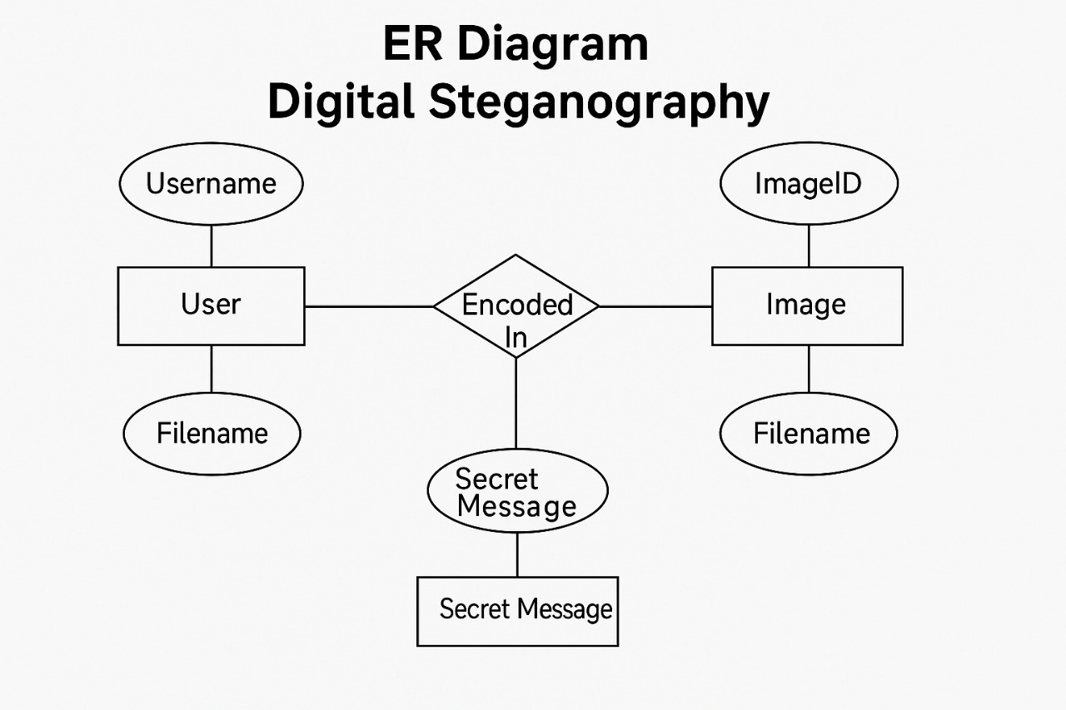

if future enhancements such as user profiling, audit tracking, or integration with cloud storage are considered.

Major Entities and Their Attributes: User:

Attributes: User_ID (Primary Key), Username, Email (optional), Role (Admin/User)

Description: Represents the end user interacting with the application. Though the current system may not require login, this entity is essential for auditability, multi-user extensions, and future personalization features.

Image:

Attributes: Image_ID (Primary Key), File_Name, File_Type, File_Size, Upload_Timestamp, User_ID (Foreign Key)

Description: Stores information about each image uploaded, whether used as a cover or stego-image. It links to the user who uploaded it and forms the foundation for the embedding/extraction operations.

Message:

Attributes: Message_ID (Primary Key), Content (Encrypted/Plain), Length, Encoding_Method, Associated_Image_ID (Foreign Key)

Description: Represents the secret message that is embedded into or extracted from an image. This entity allows detailed tracking of what content was processed by the system.

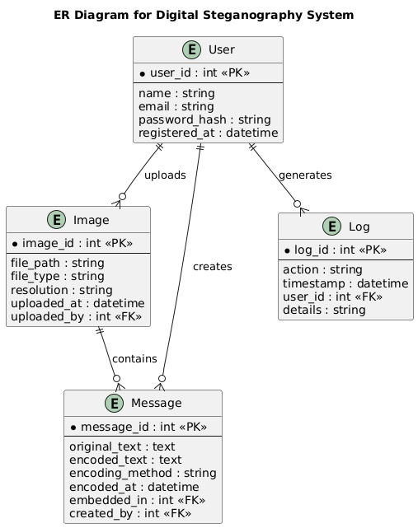

Log_Record:

Attributes: Log_ID (Primary Key), Timestamp, Action_Type (Embed/Extract), Status (Success/Fail), User_ID (FK), Image_ID (FK), Message_ID (FK)

Description: Maintains a record of all actions performed, capturing key events, errors, and user activities for auditing and debugging purposes.

Relationships: A User can upload multiple Images, enabling them to process more than one stego operation.

Each Image can be associated with one Message (per operation), establishing a one-to-one relationship during the embedding process.

Multiple Log Records may be generated for each operation, capturing the history of both successful and failed attempts.

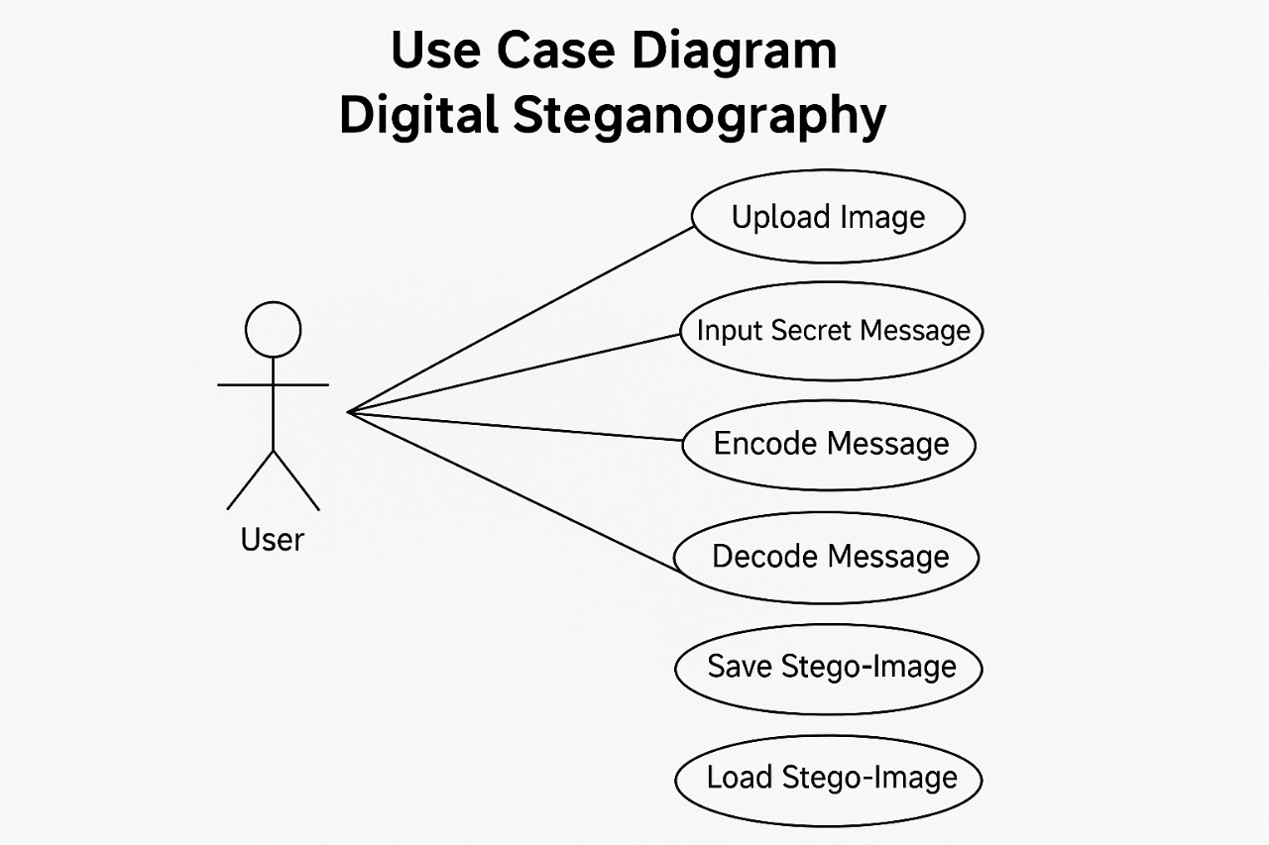

Significance: The ER diagram provides a visual guide for developers and future maintainers of the application. It clarifies data relationships and supports the integration of advanced features like:

User authentication systems

Message history tracking

Encrypted key management

Real-time logging and error analytics

Additionally, it lays a solid foundation for migrating the project into a client-server model or expanding it to support web or mobile platforms with persistent user data.

### ****4.3 Data Flow Diagram****

The **Data Flow Diagram (DFD)** of the **Digital Steganography** project is a crucial design element that graphically depicts how data moves through the system, highlighting the key **processes, data stores, external entities**, and the **data flows** between them. It provides a top-down approach to understanding the system, starting from the most abstract level (context) to more detailed layers (levels 1 and 2). This layered structure ensures a comprehensive understanding of the operations involved in data embedding and extraction, while also illustrating how data integrity, confidentiality, and validation are maintained throughout.

#### **Level 0 – Context Diagram**

At the **context level**, the DFD provides a bird’s eye view of the entire system. There are two primary actors: the **User** and the **Steganography System**. The user interacts with the system by providing two inputs:

* A **cover image** (in PNG/BMP format)
* A **secret message** (text to be hidden)

The system processes this information and generates an output:

* A **stego-image** (with the embedded message)
* Or, in the case of extraction, the **retrieved hidden message**

This diagram illustrates that all internal processing is abstracted, and only inputs and outputs are visible to the external user, ensuring a simple and clear interface.

#### **Level 1 – High-Level Functional Breakdown**

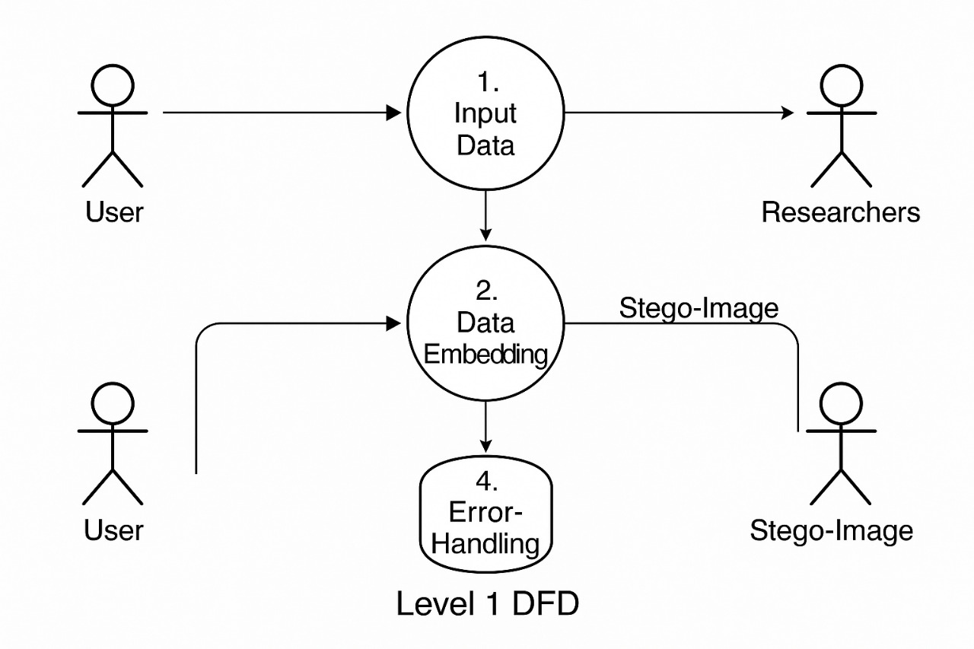

Level 1 expands the system into two major internal processes:

1. **Embedding Process**
2. **Extraction Process**

Both processes rely on input from the user (image and message for embedding, stego-image for extraction). Additionally, the embedding process may utilize an optional **Encryption Module**, which encrypts the message before embedding it into the image.

* The **Embedding Process** takes the original image and secret message, validates them, optionally encrypts the message, and then calls the LSB algorithm to embed the binary version of the message into the image pixels.
* The **Extraction Process** retrieves pixel data from the stego-image, reverses the embedding process (using LSB decoding), optionally decrypts the data (if encrypted), and reconstructs the original message for display.

Each process also interacts with **validation and file management modules** to ensure successful execution and file storage.

#### **Level 2 – Detailed Operational Flow**

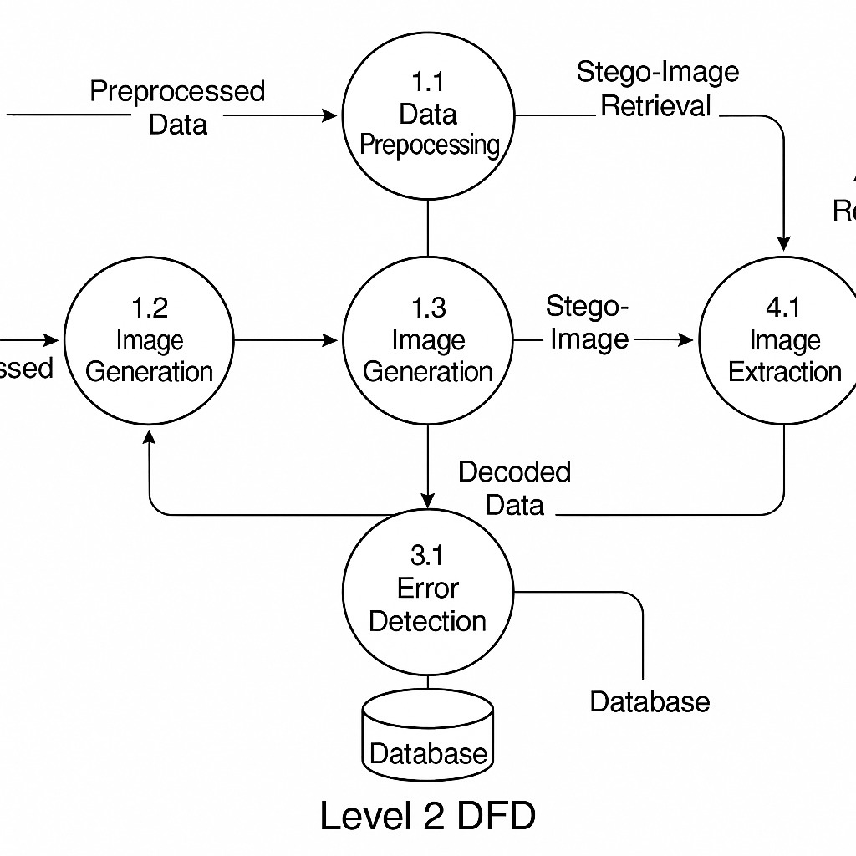

At this level, the DFD delves deeper into the internal mechanisms of each high-level process. It includes:

* **Image Validation**: Checks if the selected image is compatible (BMP/PNG) and has sufficient capacity for the message.
* **Message Validation**: Ensures that the message length does not exceed the calculated capacity of the image.
* **Pixel Manipulation**: Converts message to binary and embeds it into the image using **Least Significant Bit (LSB) Replacement**.
* **Binary Conversion Module**: Converts ASCII text to binary and vice versa during encoding and decoding.
* **Error Logging Module**: Captures and records any anomalies such as unsupported file formats, insufficient image capacity, or corruption.

All operations maintain **data confidentiality** and **information fidelity** while being invisible to the end-user. The DFD clearly maps how input data flows through multiple stages and transformations before becoming the final output.

In conclusion, the DFD of the Digital Steganography system serves as a vital analytical tool for understanding the **functional architecture**. It ensures transparency in how sensitive information is handled, how user actions translate into system responses, and how internal logic ensures **data security, reliability**, and **system robustness**.

### ****5 Project Outcome****

The **Digital Steganography** project has successfully fulfilled its core objective of delivering a **secure, efficient, and user-friendly software solution** for concealing sensitive textual information within digital image files. Built using **Java** and incorporating the **Least Significant Bit (LSB)** steganographic technique, the system offers a discreet way of hiding messages without affecting the visible appearance of the image. This makes it ideal for use in scenarios where data confidentiality must be maintained without drawing attention to the act of communication itself.

The primary achievement of the project lies in its **practical and real-world applicability**. In an age of increased surveillance and frequent digital breaches, the ability to hide the **existence** of communication itself—rather than just encrypting its contents—is a major security advantage. The project effectively addresses this need. Users can upload lossless image formats like **BMP or PNG**, input a confidential text message, and use the system to embed this message seamlessly into the image. The system then allows users to extract the message at a later point, ensuring both **accuracy and integrity** of the hidden data.

From a user perspective, the system is intuitive and accessible. The **Graphical User Interface (GUI)**, developed using Java Swing, simplifies the interaction by allowing drag-and-drop functionality, real-time validation messages, and clear prompts. Even users with minimal technical expertise can operate the application with ease, making it suitable for **journalists, whistleblowers, corporate professionals, and law enforcement agencies** who may need to communicate covertly.

Moreover, the project is designed with **cross-platform compatibility** in mind. Thanks to Java’s platform-independent nature, the application can run on **Windows, Linux, or macOS**, provided the Java Runtime Environment (JRE) is installed. This flexibility enhances its deployability in diverse environments, including low-resource or offline settings where cloud-based encryption tools may not be available.

The system also incorporates **optional encryption and validation features**, ensuring that even if the stego-image is intercepted, the message remains unintelligible without the correct decryption key. The validation module checks for message length, image compatibility, and possible format mismatches before embedding, reducing the risk of errors or incomplete operations.

Importantly, the project is **modular and extensible**, allowing for easy future enhancements. Potential upgrades include:

* Support for **audio and video steganography** (e.g., MP3, MP4 files),
* Development of a **mobile or web version** for broader accessibility,
* Integration of **advanced cryptographic algorithms** like AES or RSA for dual-layer security,
* Creation of a **StegoChat** or **StegoMail** platform for covert peer-to-peer communication.

Beyond its functionality, the project also serves as a valuable **educational platform**. It helps students and developers grasp key concepts in **cybersecurity, image processing, file I/O, GUI development, and data encoding techniques**. By working on this project, learners gain hands-on experience with real-world problem-solving, debugging, and user-centric software design.

In conclusion, the **Digital Steganography** project not only delivers a working tool for covert communication but also contributes to the evolving landscape of secure data transmission technologies. It reflects the potential of simple yet effective methods in enhancing digital privacy and stands as a strong foundation for academic research, professional development, and future innovation.

### ****6. References****

1. Johnson, N. F., & Jajodia, S. (1998). Exploring Steganography: Seeing the Unseen. IEEE Computer, 31(2), 26–34.  
   – A foundational paper introducing key concepts and applications of steganography in the digital realm.
2. Katzenbeisser, S., & Petitcolas, F. A. P. (2000). Information Hiding Techniques for Steganography and Digital Watermarking. Artech House.  
   – A comprehensive textbook detailing theoretical and practical methods for data hiding, including steganography and watermarking.
3. Provos, N., & Honeyman, P. (2003). Hide and Seek: An Introduction to Steganography. IEEE Security & Privacy, 1(3), 32–44.  
   – Discusses the strengths and limitations of steganographic systems, focusing on LSB methods.
4. Oracle. Java™ Platform, Standard Edition 17 Documentation.  
   <https://docs.oracle.com/en/java/javase/17/>  
   – Official Java documentation used for referencing Java classes, APIs, and development practices.
5. LSB Steganography Tutorial. GeeksforGeeks.  
   <https://www.geeksforgeeks.org/steganography-in-java/>  
   – A tutorial that explains LSB-based steganography using Java with example implementations.
6. Swing Tutorial – Oracle Java Documentation.  
   <https://docs.oracle.com/javase/tutorial/uiswing/>  
   – Official guide for building GUI applications in Java Swing.
7. javax.imageio Package Documentation – Oracle.  
   <https://docs.oracle.com/javase/8/docs/api/javax/imageio/package-summary.html>  
   – Details image processing and I/O functionalities essential for embedding/extracting data.
8. Krylov, A. (2019). Steganography Methods and Their Applications in Digital World. Journal of Information Security.  
   – Discusses modern steganographic algorithms and their role in secure digital communication.

### ****7. Bibliography****

* **Schneier, Bruce.** Applied Cryptography: Protocols, Algorithms, and Source Code in C. Wiley, 1996.  
  This foundational text offers deep insight into the field of cryptography, covering various encryption algorithms, protocols, and their real-world implementations. It's essential for understanding the encryption layer that can complement steganographic systems.
* **Menezes, A. J., van Oorschot, P. C., & Vanstone, S. A.** Handbook of Applied Cryptography. CRC Press, 1996.  
  A comprehensive reference that covers the mathematical and algorithmic foundations of cryptography. This book is valuable for anyone aiming to integrate cryptographic techniques into steganographic systems.
* **Katz, Jonathan, and Yehuda Lindell.** Introduction to Modern Cryptography. CRC Press, 2007.  
  This book bridges theory and practice, focusing on the principles of secure communication. It’s particularly useful when combining modern encryption with data-hiding methods.

#### **Websites**

* [TutorialsPoint Java Tutorial](https://www.tutorialspoint.com/java/index.htm)  
  Offers structured tutorials covering core and advanced Java concepts, helpful for developing and understanding the backend logic of Java-based steganography tools.
* [GeeksforGeeks](https://www.geeksforgeeks.org)  
  Provides numerous code examples, particularly for image processing, file handling, and GUI development in Java, which were instrumental in implementing LSB techniques.
* [JavaTpoint](https://www.javatpoint.com/java-tutorial)  
  Contains clear explanations of Java fundamentals, Swing, JavaFX, and I/O streams—core components of the project architecture.

#### **Research Articles**

* **Cheddad, A., Condell, J., Curran, K., & Mc Kevitt, P. (2010).** Digital image steganography: Survey and analysis of current methods. Signal Processing, 90(3), 727–752.  
  An in-depth review of existing image steganography techniques, performance metrics, and their comparative strengths and weaknesses.
* **Bender, W., Gruhl, D., Morimoto, N., & Lu, A. (1996).** Techniques for data hiding. IBM Systems Journal, 35(3.4), 313–336.  
  A seminal work discussing data hiding principles and technologies, laying the groundwork for modern steganographic systems.